Get NULL Values for the Report

For this first we need to create the data type with fields and columns and with some blank columns.

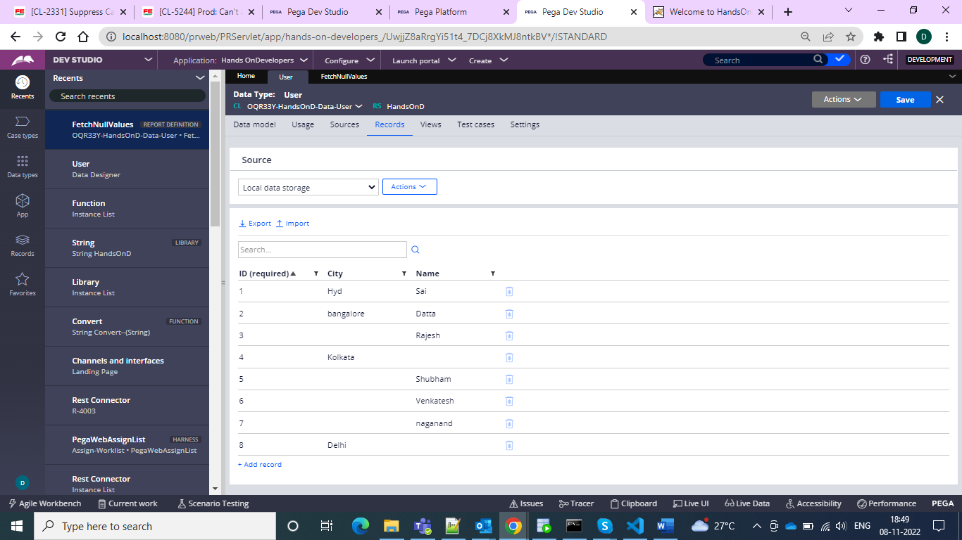

And in the same data class create a report and then use functions

pxCheckBiasCategoryNull [Check if null] [Return this if null] [else return this]

and inside that we need to give the property name and if null then return 1 and then go for 0

and give in the summarize column as sum and save and run

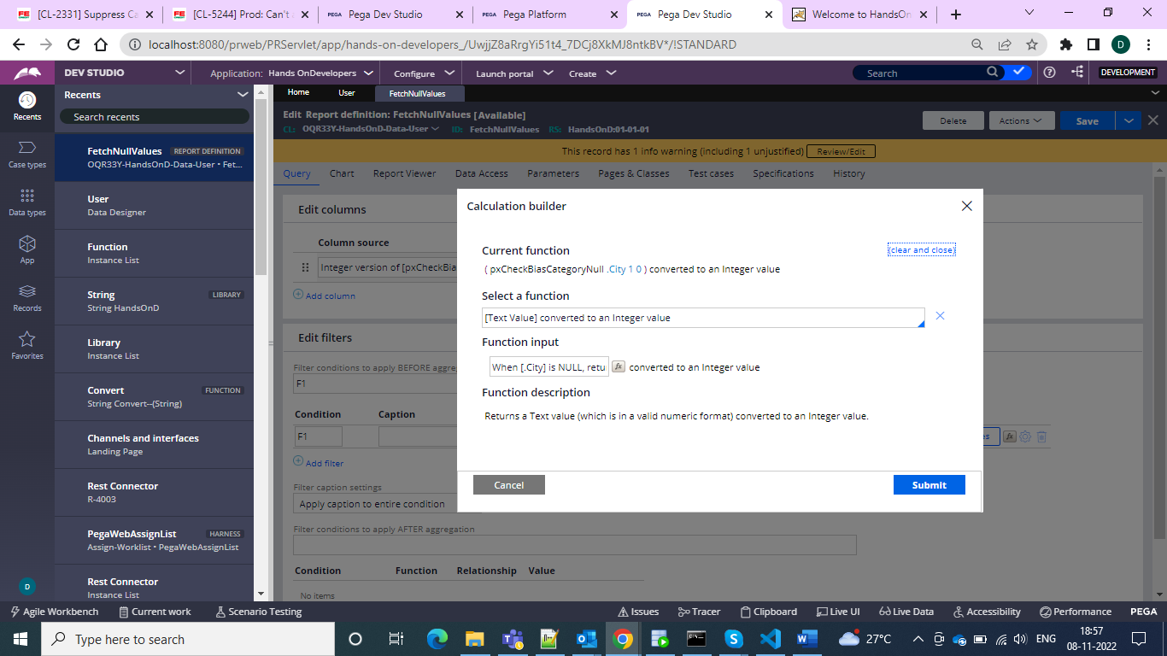



And hence in my data type there are 4 null values so shown as 4

